Software Requirements Specification

For

GYM MANAGEMENT SYSTEM

Prepared by:

Sheraz Channa (9269)

Muhammad Hamza Abbasi (9847)

Yaqoob Khan (9531)

Sameer Mustafa (9524)

Mohammad Hunain (9409)

Table of Contents

1. Introduction

**1.1 Purpose**

**1.2 Intended Audience and Reading Suggestions**

**1.4 Product Scope**

2. Overall Description

**2.1 Product Perspective**

**2.2 Product Functions**

**2.3 User Classes and Characteristics**

**2.4 Operating Environment**

**2.6 User Documentation**

3. External Interface Requirements

3.1 User Interfaces

3.3 Software Interfaces

4. System Features

4.1 System Feature 1

5. Other Nonfunctional Requirements

5.1 Performance Requirements

5.2 Safety Requirements

5.3 Security Requirements

# Introduction

## Purpose:

This project is designed to facilitate a gymming and fitness center to automate its operations of keeping records and store them in form of a large and user friendly database further facilitating easy access to the personnel.

## Intended Audience and Reading Suggestions:

The main objective of the project on Gym management system is to manage the details of Gym, Attendance, Gym Shift, Package, Trainer. It manages all the information about Gym, payment, Trainer, Gym. The project is totally built at administrative end and thus only the administrator is guaranteed the access.

## Product Scope

The Project was made in order to effectively and efficiently cater to requirements of the fitness center. Very frequently the person who generally holds the tasks to manage the center needs to keep records of all the transactions as well as data annually. Generally, In order to structure these tasks Separate Registers are maintained. This whole process thus becomes quite cumbersome for them to control manually. Moreover, Any wrong data entered mistakenly can brings serious results. The cost of maintained of data and records of occurrence of transactions is very high. So for this the software is required for the admin.

The software is capable enough to allow the concerned person to store and retrieve any type of record with just a single click of mouse. The software allows Interactive ,Self decribing Graphic User Interface environment where even standalone users can work very comfortably and easily.

# Overall Description

## Product Perspective

This project named gym management system is desktop application which shall enable the user to add members to a gym and manage the fee payment of the gym user.

It is a very simple interface developed using .net. The user of the system shall be able to add a new gym member. The tool shall add all the necessary details like name, admission date, contact details into the system.

The system shall also monitor the timings for the member. It shall allow the user to make fee payments. This tool shall hold all the details of gym members. It shall enable the user to make payments monthly, quarterly or annually.

**Internal Interfaces:**

Database:

* Creates reports
* Stores data
* Provides access to data
* Updates information

Desktop Server:

* Provides access to the database
* Authenticates users
* Processes information
* Performs backups
* Produces reports

**External Interfaces:**

Personal Computers:

* Users:

1. Administrator

**Computer Hardware and Peripheral Equipment to be used**:

* Personal Computers (i.e. CPUs, monitors, keyboards, and mice).
* Printers
* Network

## Product Functions

This tool is basically developed to aid the user to add a member to the gym. The user shall be able to add the name, date of birth and contact address of the member.

It also records the phone numbers and the height and weight data of the member. It shall have the admission date. It also has an option to check whether the member is new or an existing one.

It stores the photo of the member. It shall help the user to know about fee payments. It has the option to select type of fee payments. It could be monthly, quarterly or annually depending on the choice of the member. It also holds the receipt number and the amount of fees paid.

It shall also generate reports based on the payment of fees. It shall also enable the user to update information of members. This tool uses .net framework with MS SQL Server as the database. It secures the data of each user. Storage and retrieval of data is fast through these .net tools.

## User Classes and Characteristics

The users of the system are the Administrator (Admin) who maintain the system.

The user should be familiar with the following:

* Working on a desktop Application
* Searching the required information
* The user should know the details of a transaction
* Basic functionality and flow of application.

## Operating Environment

Operating environment for the system as listed below:

* Distributed Database
* Operating System: Windows 7/10.
* Database: MS SQL Server
* Platform: Visual Studio 2015/ 2013/ 2012

## User Documentation

Documentation can take the form of online documents, PDFs, video walk-through and printed manuals. It should cover each function within your extension.

Good quality documentation needs to reflect the actual functionality of the current version of the extension. Ideally it should be cross-referenced and searchable. No matter which software you choose to help you create your documentation, the processes involved are always the same.This isn't as simple as it sounds.

There might be the average user, the more experienced designer, a knowledgeable developer or even a system administrator. You can assume that the vast majority of your readers will not read the documentation before trying your product.

Most people only turn to the documentation when something unexpected occurs and they need guidance. One user guide might not serve the needs of your entire audience.

# 3: External Interface Requirements

## 3.1: User Interfaces

The project gym management system is an online platform that will cater the transactions and records of a gym facility center.

The target of this article is to provide a guide on the development of the gym management system specifically in the front-end part of the project. The main objective is to provide you with the basic concepts on what are the features that should be included in the development of gym management system. In addition, we have also included the form designs or user interfaces of the project.

**Login Form**– the login form will be used by the administrator, staff, gym instructors and members of the gym to access their respective accounts.

**Administrator can:**

* Manage user accounts (CRUD – create, update, and delete)
* Manage membership type (CRUD – create, update, and delete)
* Manage member information (CRUD – create, update, and delete), approve and disapprove the application
* Manage gym instructor information (CRUD – create, update, and delete), activate and deactivate the account
* Manage promotional material (upload banners and videos for promotion and advertisement purposes)
* Manage workout and workout plan information (CRUD – create, update, and delete)
* Manage payment (accept and void payments)
* Perform database and system maintenance.

Modules pictures of gym management system are follow:

1: DASHBOARD

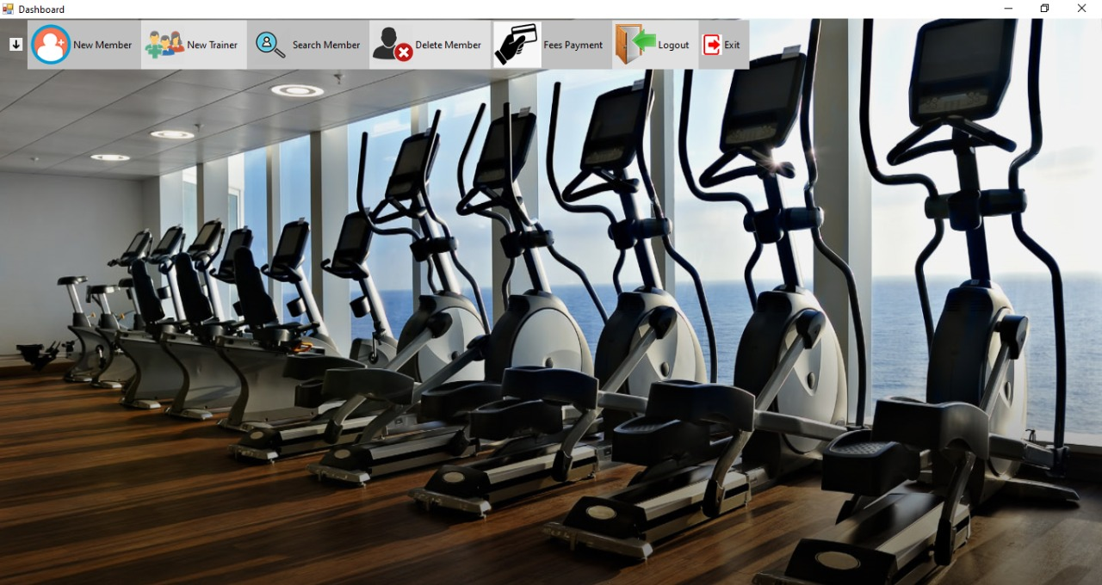

2: NEW MEMBER:

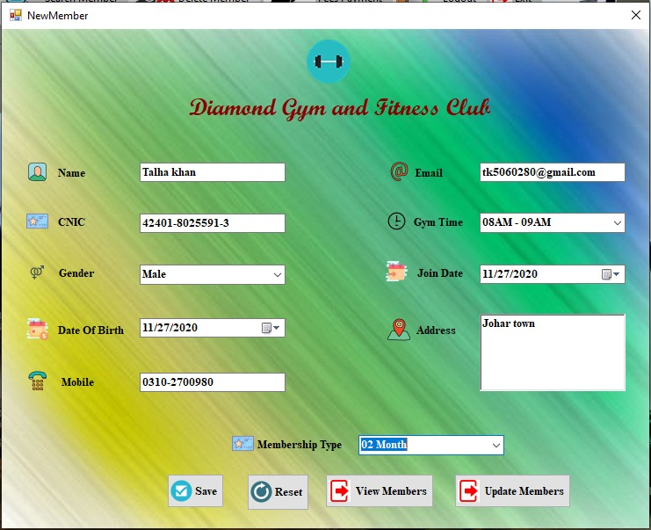

3: VIEW MEMBER:

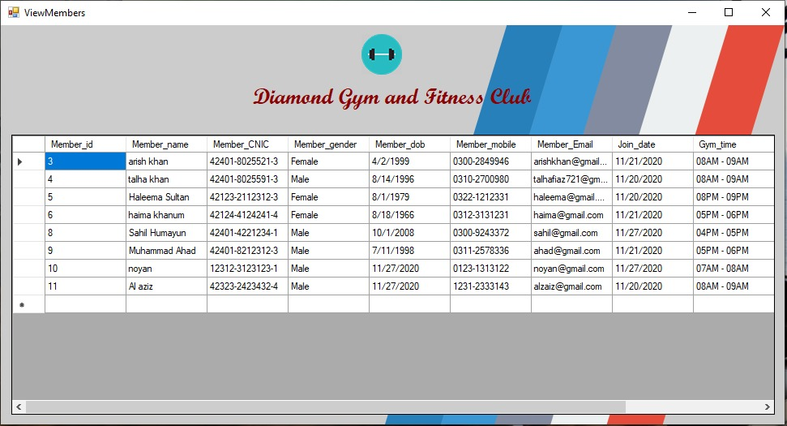

4: UPDATE MEMBER:

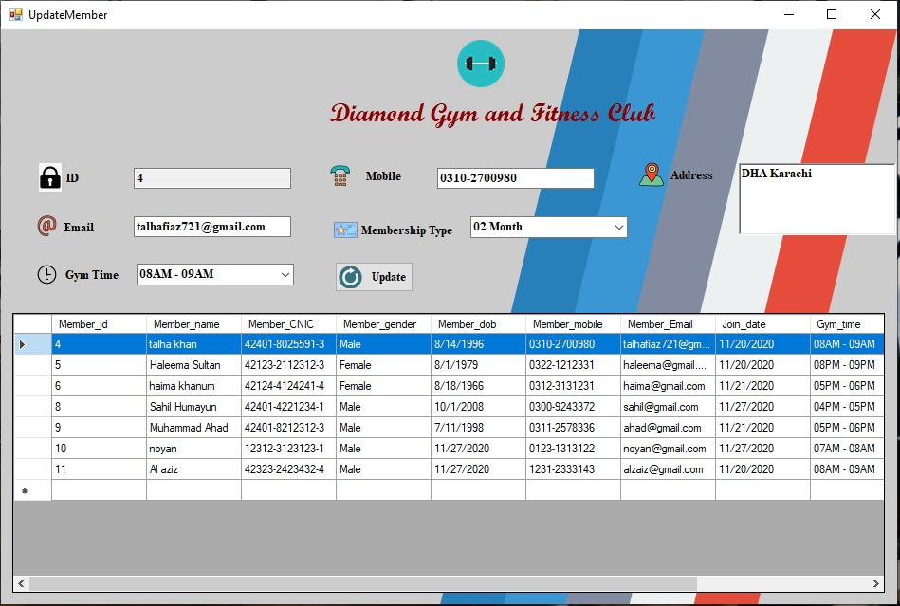

5: SEARCH MEMBER:

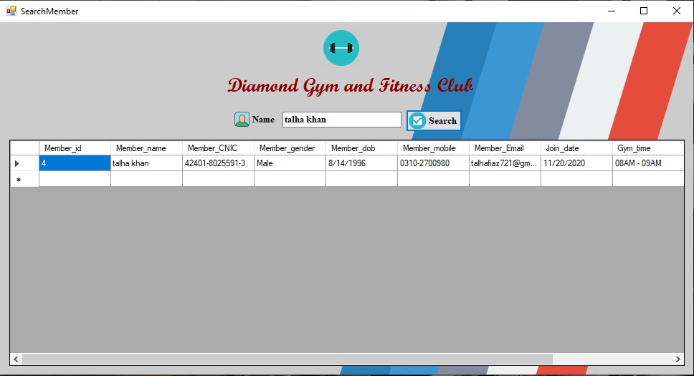

6: DELETE MEMBER:

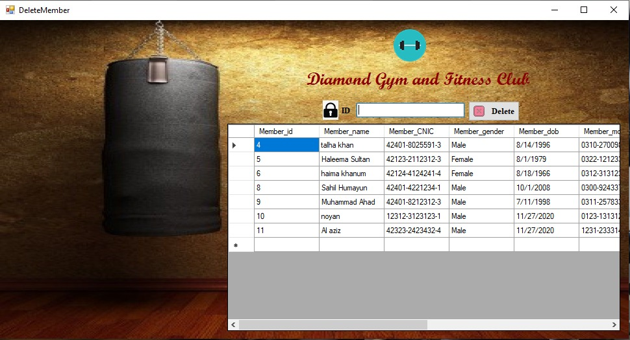

## 3.2 : Software Interfaces

*A computer language whereby computer programs can communicate with each other and one language can call upon another for assistance. We are using software interfaces as per project requires.*

*i) Sql server2008*

*ii) Visual studio 2013*

*iii) Window 10*

**4.1 Software Feature:**

GYM management system is web application designed for the managing gym data**.** Gym scheduling software is also sometimes referred to as fitness software, scheduling software or membership software. Such software solutions help businesses that offer memberships and classes keep track of their members, their employees and their schedules. Gym management system is used to assign classes or training sessions to specific employees, create membership limits on classes, onboard new members,track employee hours. Fitness trainers often use the same software to find out their upcoming schedules, see how many members are signed up for their services, and track member.

## 5.1: Performance Requirements

* The product will be based on local server.
* The product will take initial load time.
* The performance will depend upon hardware components.

## 5.2: Safety and Security Requirements

* The source code developed for this system shall be maintained in configuration management tool.
* The whole system is secured. Only Admin can access all the data.

**5.3: Module 3 complete CRUD Admin Side**

1. **Description:**

* Admin is the actor who can access the entire database and can do all the tasks. we have 2 type of admin here
* Old admin:

Old admin is the one who is already sign in to the dashboard. Admin can sign in by providing correct email and password to system. If there are more than one admin then all records of admits are saved in database.

* New admin:

New admin is the one who first have to sign up

Then system will allow him to enter the database as he will sign in to the dashboard.

* After login admin will find him-self on dashboard where he will have 7 categories
* Admin can click any option there
* If admin choose New Members:

System will display a list of New Members info that includes

1. NAME
2. CNIC
3. GENDER
4. DOB
5. MOBILE
6. EMAIL
7. GYM TIME
8. JOIN TIME
9. ADDRESS
10. MEMBERSHIP TYPE

Admin can do 4 functions

1. SAVE
2. RESET
3. VIEW MEMBERS
4. UPDATE MEMBERS

* If admin choose View Members info:

The system will automatically show all the members lists and where he can view all the lists of members.

* If admin choose Update Members info:

System will display a list of Update Members info that includes

1. NAME
2. CNIC
3. GENDER
4. DOB
5. MOBILE
6. EMAIL
7. GYM TIME
8. JOIN TIME
9. ADDRESS
10. MEMBERSHIP TYPE

Admin can do 1 function

1. Update

* If admin choose Search Members:

System will display a list of Search Members that includes

1. Name

Admin can do 1 function

1. Search

* If admin choose Delete Members:

System will display a list of booking info that includes

1. ID

Admin can do 1 function

1. Delete

* If admin choose booking status info:

System will display a list of booking status info that includes

1. Booking status

Admin can do 4 functions

1. Create

2. Delete

3. Edit

4. Details

Use Case Diagram:

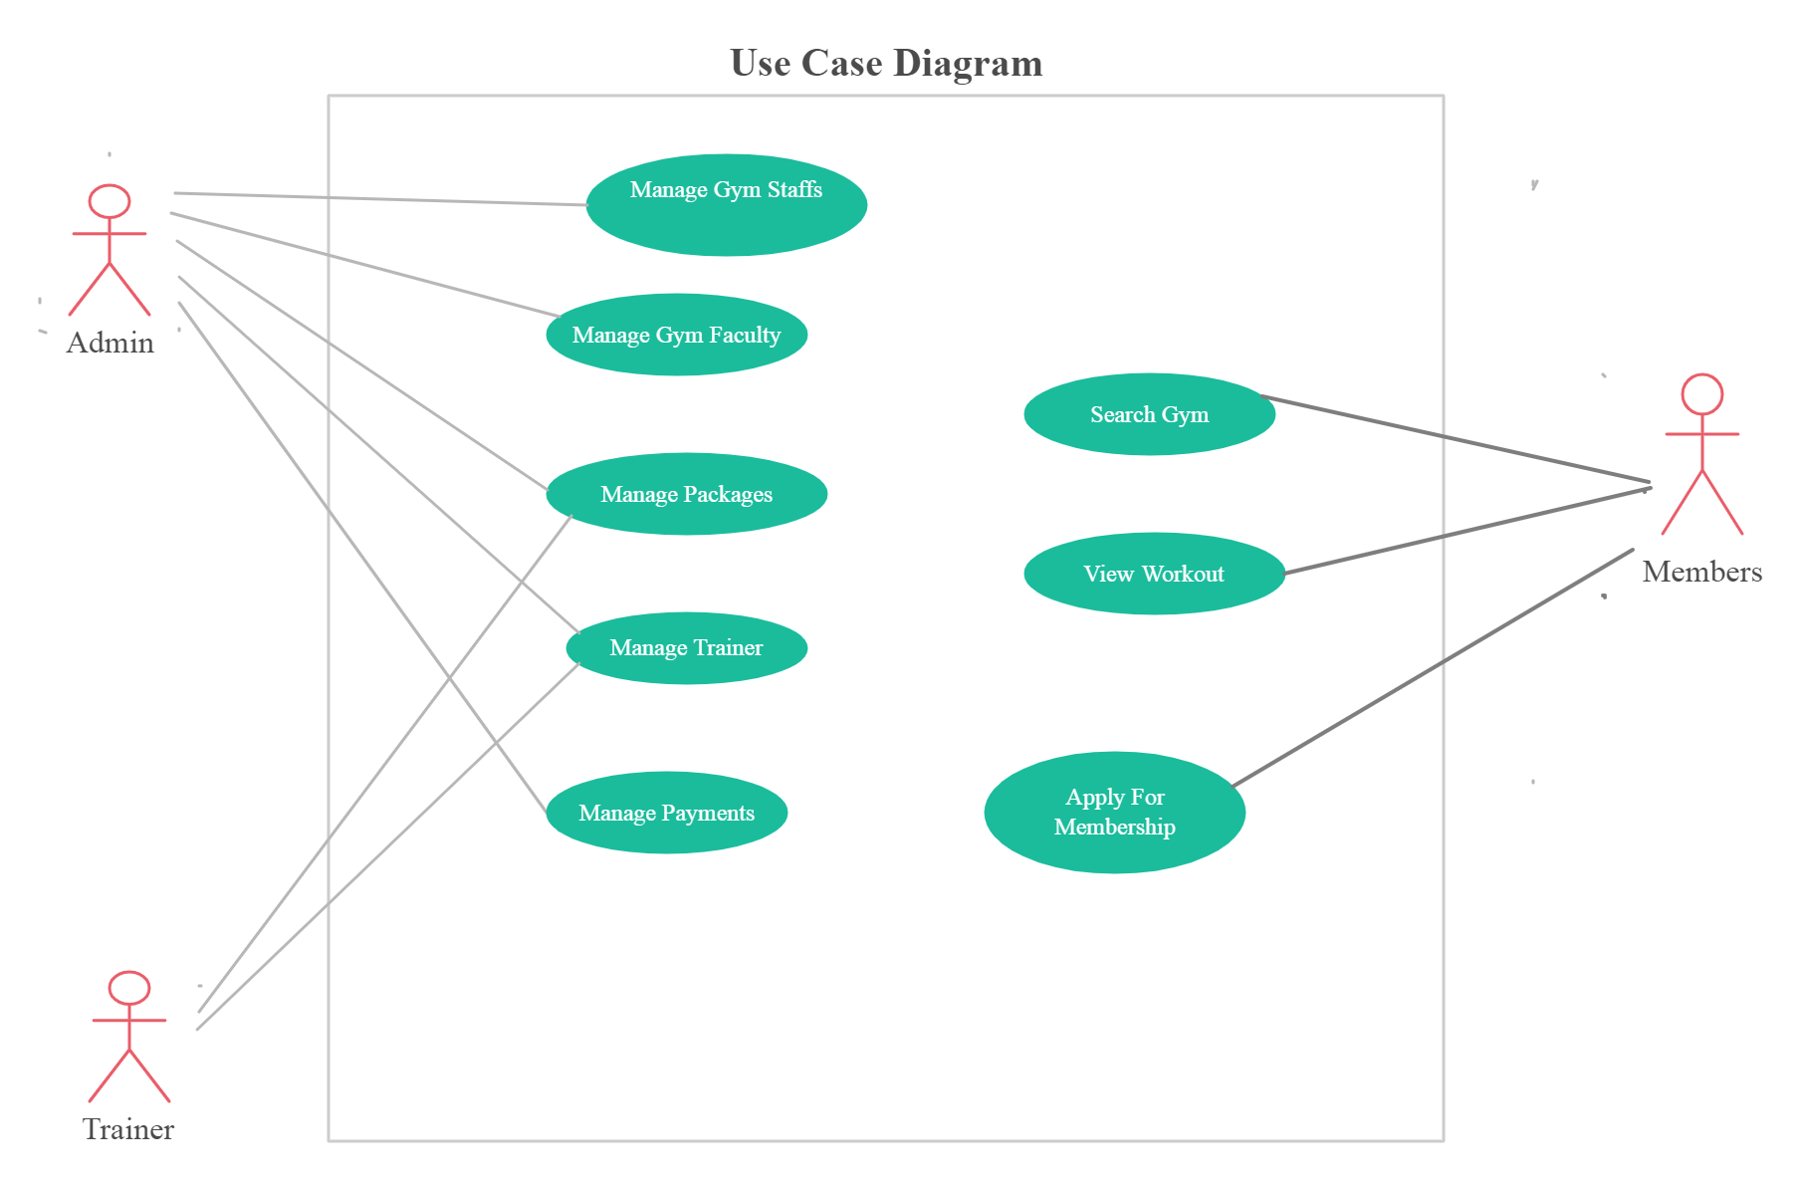

*Class diagram:*

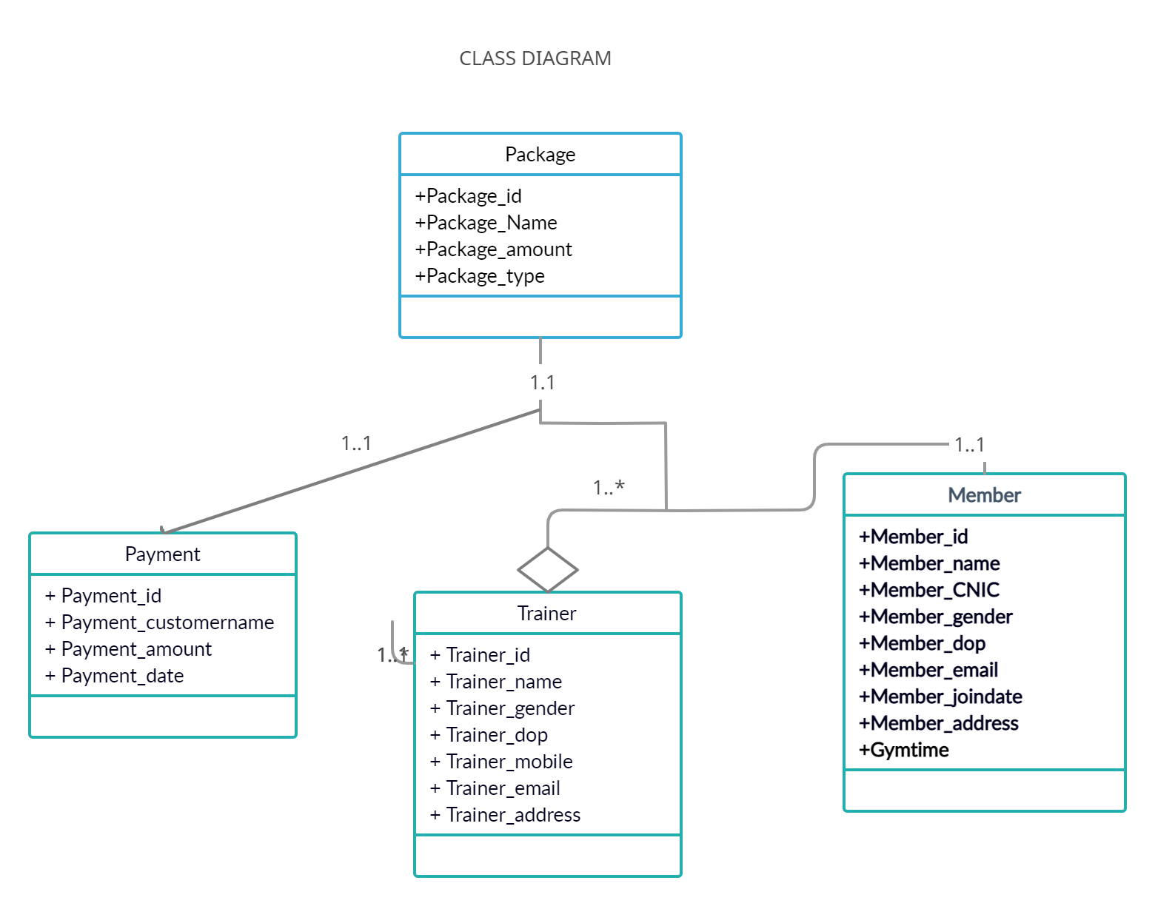

*Activity Diagram:*

# START

Check the detailed Enteredd

Check the detailed

Check the detailed

Check the detailed

Check Login

ID AND PASSWORD

Login To System

Check the detailed

Manage Trainer

Manage Package

Manage Faculty

Manage Shift

Manage Gym

Logout from System

*Sequence Diagram:*

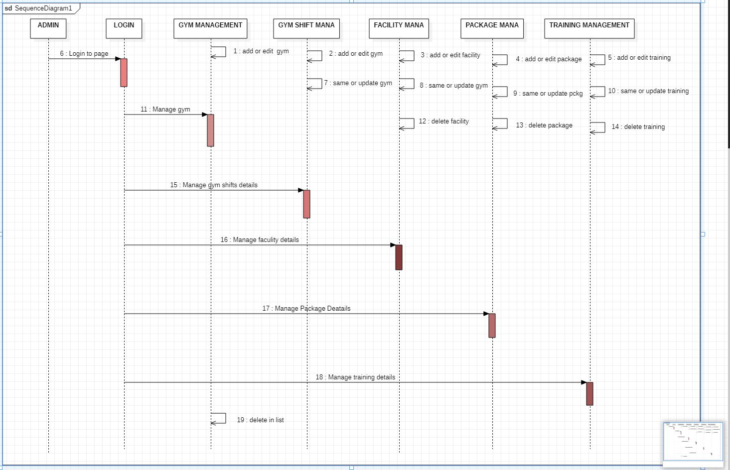

***Collaboration Diagram***

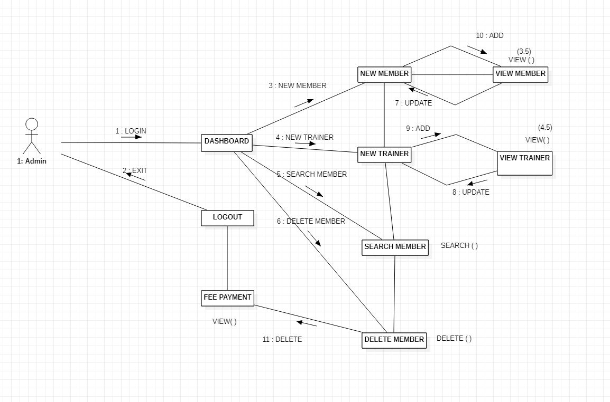

***REPOSITORY GITHUB:***



